Internship

**TestReport**

**Steppermotor water resolution**

**Student:** Casper R. Tak

**Studentnumber:** 657313

**Client**: Rudie van den Heuvel

**Coach:** Jeroen Veen

**High School:** HAN Arnhem

**Education:** Embedded Systems Engineering

**Date:** 29-11-2022

Inhoud

Objective 3

Measuring options 4

Test Setup 4

Conclusions 8

Further actions 8

# Objective

The component that will be tested in this test report will be the stepper motor resolution. This component is responsible for moving fluids from point a to point b.

Preliminary investigation

Inner volume of the pipe used is calculated using:

**volume = π × (d2/4) × h**

d = 1mm, h = 670mm

the volume will be: π × (12/4) × 670 = 526.22 cu/mm (cubical mm)

or a total of 526 microliters will be in the clear part of the tube.

Now it is important to see how much degrees the motor has to rotate to move the water 1cm in the clear tube

**volume = π × (d2/4) × h**

d = 1mm, h = 10mm

the volume moved will be: π × (12/4) × 10 = 7.85 cu/mm (cubical mm)

so 7.85 microliters is moved.

# Measuring options

|  |  |  |  |
| --- | --- | --- | --- |
| Idea number | Idea details | expected benefits | expected drawbacks |
| 1 | Check water flow through observation in clear tube | Easy set-up, no extra materials required | Eyes are not perfect, possible optical illusions and air in the tube can become a problem |
| 2 | measure water droplets weight | More precise measuring using a high precision scale (no human reading errors) | Requires extra tools and droplets could get “stuck” in the end of the tube resulting in inconsistent measurements |
| 3 | use flow sensor | Could be very precise, no issues with air or droplets that stay behind (like with the a scale | Errors in flow sensor (which is not really visible for user), difficult to see forward and backward flow, setup is time consuming |

# Test Setup

* Testing equipment:
  + Hardware:
    - Zaleae Logic 16
    - TMC2209 stepper driver set to 64microstepping
    - BJ-RZ1030-4 stepper motor (12V)
  + Software:
    - VSC
    - SSH connection to RPI
    - Logic 2.3.45

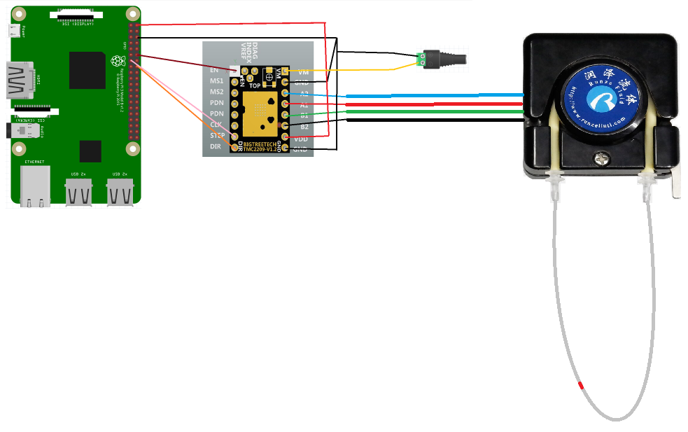Hardware setup:Test Results

Figure 2: Waterflow scale test

Figure 1: Water loop setup

|  |  |  |  |  |  |  |
| --- | --- | --- | --- | --- | --- | --- |
| Test (water loop) | Test passed if: | Observations | Test passed | Test Failed | Pictures | Notes |
| T1.0 | Water is contained and clearly flowing from point A to B in this form. | Water is mixing with the pigment, therefore it is not possible to see the exact water flow |  | X |  |  |
| T1.1 | An “air train” or long air bubble is contained and clearly flowing from point A to B in this form. | The “air train” is not consistently flowing with the water, water passes the air. |  | X |  |  |

|  |  |  |  |  |  |  |
| --- | --- | --- | --- | --- | --- | --- |
| Test (Scale) | Test passed if: | Observations | Test passed | Test Failed | Pictures | Notes |
| T1.0 | The weight on the scale increases with roughly the same step with every droplet added | The scale is showing a constant  (Linear) increase every time the motor turn 360 degrees command is send | X |  |  |  |

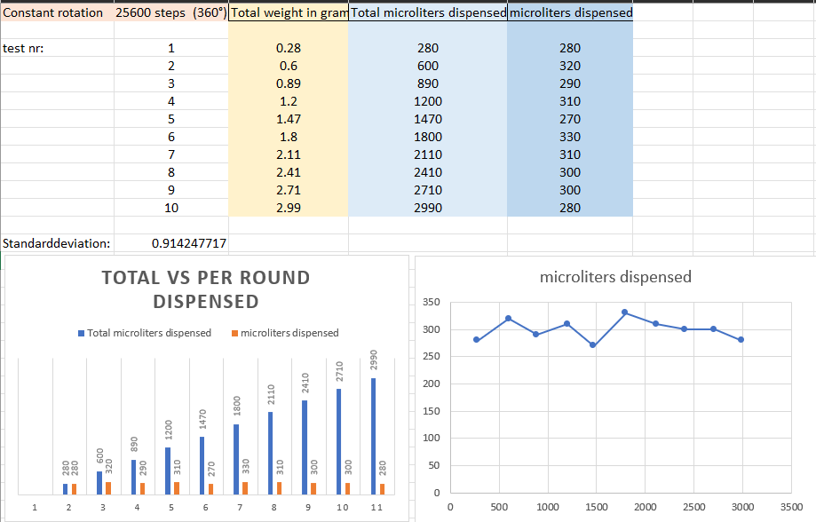

# Conclusions

* The water dispensing is quite accurate but I think that the mechanical part (the rollers on the tube) is creating a inconsistency in the dispense. This is most likely not something that can be resolved easily, since this is how to pump works. I suspect that the dispensing will become more unstable as the tube gets scratched time after time. Therefor I think it is wise to find an alternative pump or to use a flow sensor in combination with this pump (feedback) system. Another option is to use a syringe pump. This was already implemented in the S6 project from 2021. We could refine this pump system so it is significantly more compact.

# Further actions